First Name:

FRESH 2019

Application form
Surname:
Trading name (if applicable):
Postal Address:
Studio Address (if different):
Telephone:
Email:
Web address:
Year of Graduation: ___________________
If selected as a FRESH exhibitor would you like to be considered for the residency
opportunities (Please delete as appropriate):
Guldagergaard ICRC residency in 2019 Yes No

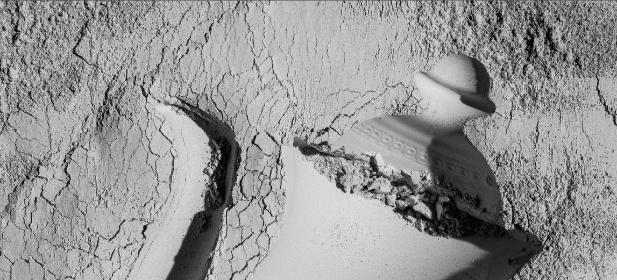
The application check list:
Artists/Designers/Makers are invited to apply by submitting:
[ ] Completed applicant information.
[ ] An artist statement
[ ] A brief CV (1 page only).
[ ] Up to 6 illustrations/photographs of planned/existing work (made within the last 3 years). Image quality should be min. 300dpi and jpeg or pdf.
[ ] Image list (Image details must correspond to image file title and must include: Work title, date, materials, dimensions, photographer).

The documents should be sent wetransfer.com only. Please send your application to rhiannon@britishceramicsbiennial.com, with the subject heading ‘FRESH 2019 Application’.

Note: All submission materials must be marked with your name and contact details. Please provide a photographer credit where applicable.

