Final draft
Call for UK-based artists: AWARD at the British Ceramics Biennial
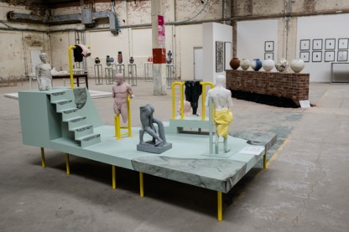
The British Ceramics Biennial invites UK-based artists, who use clay as their primary creative medium, to apply for AWARD 2021.
AWARD is the headline exhibition in the British Ceramics Biennial, the international ceramics festival held in Stoke-on-Trent. It is a prestigious opportunity for artists who are at a critical moment in their careers and are pushing at the boundaries of both their individual practice and contemporary ceramics practice. Applications are welcome from individual artists, collaborators or collectives who want to use the opportunity to tread new ground or present work in ways that it hasn’t previously been experienced.
A selection panel of specialists within the field of contemporary ceramics, chaired by Alun Graves, Senior Curator in Ceramics and Glass at the V&A, will select a shortlist of 10 artists to take part in AWARD. Each artist will be awarded £1,000 towards the exhibition of their work as a central component of the next British Ceramics Biennial festival, which takes place in the China Hall of the original Spode factory in Stoke-on-Trent from 11 September to 19 October 2021. One winner will be awarded a £5,000 prize and will also be invited to exhibit in the 2023 BCB festival and to sit on the 2023 AWARD selection panel.
Chair of the selection panel, Alun Graves comments: ‘AWARD is a showcase for ground breaking and progressive practice, capturing the breadth and dynamism of artists engaging with clay today. It is an opportunity for ambition, and for new ideas to be explored and presented in a truly remarkable and historic location.’
Vicky Lindo and William Brookes were the winners of AWARD in 2019 for their body work ‘Dead Dad Book’, which has since been acquired for the V&A’s collection.
The deadline for applying is midnight on 8 December 2020. Further information about the application criteria and the BCB festival can be found on the website: www.britishceramicsbiennial.com
Facebook: @britishceramics.biennial
Twitter: @BCBfestival
Instagram: @british_ceramics_biennial

-Ends-

For more press information, please contact Iliana Taliotis on +44 (0)7931 341 112 or mail@ilianataliotis.com

Notes to editors

About the British Ceramics Biennial:

British Ceramics Biennial (BCB) is the UK’s premiere contemporary ceramics festival that takes place in Stoke-on-Trent. BCB presents artworks from the UK’s leading ceramicists alongside international artists, in exhibitions and special events held across the city. BCB is underpinned by an exciting year-round programme of artists’ commissions, education and community engagement projects.

British Ceramics Biennial is a prestigious project that embraces the heritage of the Potteries as the home of British ceramics; that stimulates creativity and innovation across the breadth of its practice and sharpens Stoke-on-Trent’s creative edge as an international centre for excellence in contemporary ceramics.

Initiated in 2009, BCB has grown to be the single largest ceramics event in the UK, a flagship cultural project for Stoke-on-Trent City Council, and a catalyst for regeneration. BCB has been successful in bringing great art, creative energy and critical attention to the city, and has facilitated meaningful new public engagement with local communities, visitors and cultural tourists.

The next British Ceramics Biennial festival takes places from 11 September to 19 October 2021.

British Ceramics Biennial funders:

The British Ceramics Biennial Ltd is funded by Stoke-on-Trent City Council and Paul Hamlyn Foundation and is supported using public funding by Arts Council England.

