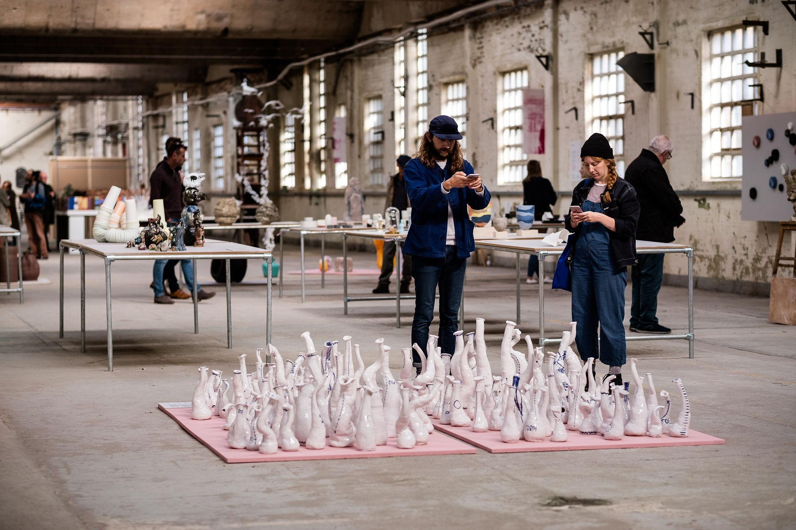
Fresh exhibition in BCB 2019. Photographer: © Jenny Harper. Work in foreground: Trans Forms, Rose Schmits
Fresh – Call for Artists

“Being a part of Fresh has helped me to dream bigger. I’m looking forward to what the future holds.”
Laura Plant, Fresh Talent
award winner 2019

Emerging artists are invited to apply for British Ceramics Biennial 2021 Fresh exhibition, taking place in Stoke-on-Trent from 11th September to 17th October 2021.

Deadline for applications: Midnight June 16th, 2021

Fresh exhibition in BCB 2019. Photographer: © Jenny Harper.
Work on the left: Transect, Steven Sales. Work on the right: Meanderings in Time, Gina Baum.
Fresh
“BCB has given me further opportunities to exhibit, showcase, sell, challenge and innovate my work and truly a pivotal moment where my career as a ceramicist has flourished."
Toni de Jesus, Fresh Talent
award winner 2019
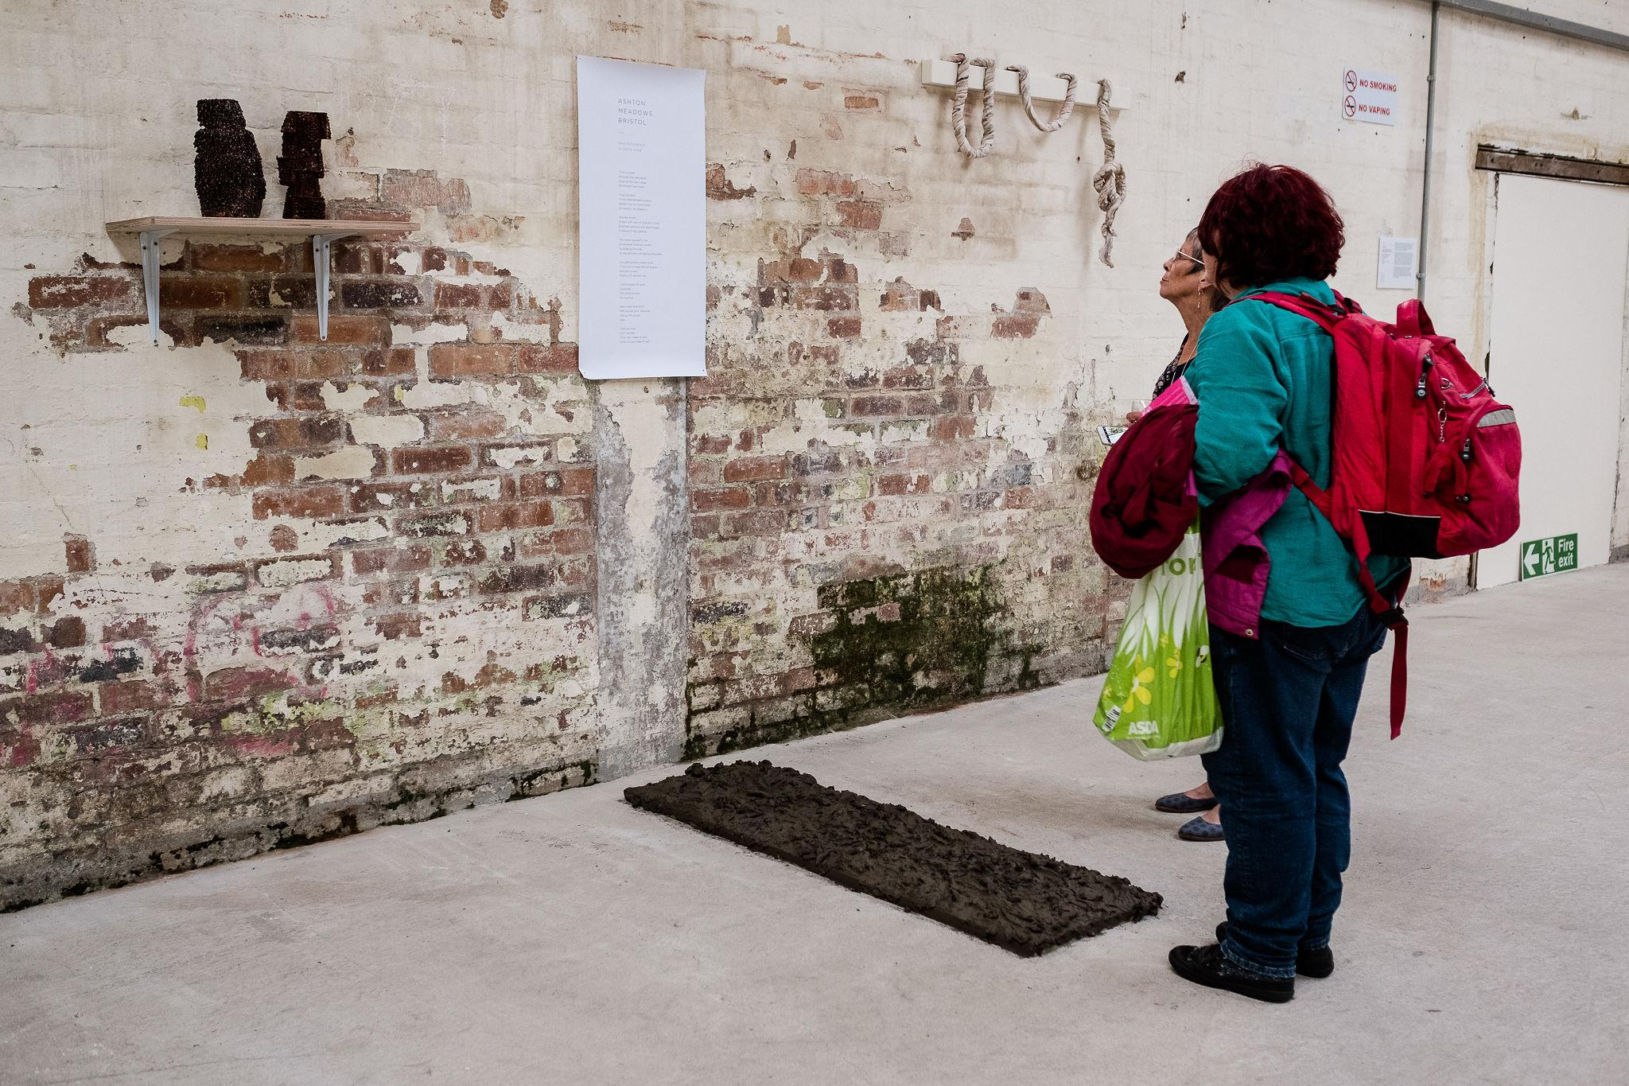
The Fresh exhibition celebrates and promotes emerging talent in contemporary British ceramics. Fresh 2021 will provide a new platform for artists to inspire and challenge, bringing focus to the rich and diverse learning opportunities, which are shaping ceramics today.
Twenty-five exhibitors will be selected by a panel composed of artists, makers, educators and learning designers. Fresh will be situated in the China Hall on the former Spode factory site as part of the British Ceramics Biennial festival programme of exhibitions, projects and engagement.

Fresh is delivered by the British Ceramics Biennial with funding support from the Schroder Charity Trust and in association with the National Association for Ceramic Educators. The Fresh Talent Residencies take place through partnership with Staffordshire University and Guldagergaard International Ceramics Research Centre.

Deadline for applications: Midnight June 16th, 2021

Fresh

“Fresh provides a unique platform for early career practitioners to exhibit their work at the British Ceramics Biennial. It showcases a diverse cross-section of ideas and trends currently explored within clay and ceramics practice and offers opportunities to forge new networks both nationally and internationally. Emerging talent can acquire a presence alongside a range of established artists and designers through the UK’s largest festival that champions the boundless possibilities of the material.”
Neil Brownsword, Artist and
Professor of Ceramics,
Staffordshire University.
What is Fresh looking for?
Fresh is looking for artists at a launch moment in their practice. This is an exhibition that platforms a cross-section of emerging talent, celebrating artistic discovery, which shows the courage of new beginnings. Fresh 2021 seeks to represent artists coming from a variety of learning experiences – from community workshops to degree programmes, apprenticeships and more.

Who is Fresh for?
Fresh invites applications from early career UK based individual practitioners or collaborators who use clay as their primary creative material. Applicants must have been practicing between 3 – 7 years including time in education/learning and be able to show a continued engagement in practice (for more detail in regards to eligibility please see the “Who is eligible?” section in this form and to see what we mean by “continued engagement in practice” see the Questions and Answers at the bottom of this document).
The Fresh exhibition seeks to have a positive impact on the practice of the exhibiting artists. We seek to support artists who want to make best use of the opportunity, who are at the beginning of their career and wish to use the momentum of the exhibition as a launchpad.
“It was awe inspiring to have been shown within the significant setting of the China Hall, part of Spode Factory, in Stoke-on-Trent, and to be now a part of that history and of the people that walked before me.”
Pam Su, Fresh Talent
award winner 2019
What do the shortlisted artists receive?
Each exhibitor in Fresh will receive £200 exhibition payment and £50 towards the transport of the work to and from the exhibition venue. Fresh exhibitors will benefit from a national PR and marketing campaign.

Fresh Talent awards will be given to a number of exhibitors. The awards are intended to continue in offering a number of extended residencies hosted in Stoke-on-Trent by British Ceramics Biennial, Staffordshire University and local partners and with Guldagergaard ICRC. The Fresh Talent award winners will have a group exhibition in BCB 2023. More information will be announced in due course.

What is expected from the shortlisted artists?
Artists are invited to apply for Fresh by submitting an application, proposing what they wish to exhibit. The artists shortlisted must produce the work in line with the original application. The work submitted must already exist and be made within the last 3 years. Artists are responsible for delivering and collecting their own exhibit with reasonable practical support from the festival team where possible and within the team’s capacity.

Who is eligible?

- Applicants must have been practicing between 3 – 7 years and have an ability to show a continued engagement in practice, including time in education or learning. (please see applicant examples)
- Applicants must have embarked on their professional careers and must have been based in the UK between September 2019 – September 2021.(please see applicant examples)
- Applicants must be proposing exhibits that use clay as the primary material/medium. Fresh seeks to represent a range of practice of early career artists within the field, and accepts work from across the ceramic spectrum including but not exclusive to: studio pottery, design, socially engaged practice, sculpture, performance, installation, objects, film and audio.
- Applicants can be working as an individual artist or in collaboration with others. A collaboration may take place between artists or between an artist and community group in the creation of the proposed exhibit. All artists involved must be early career and between 3-7 years of practicing.

Applicant examples can include but are not exclusive to:

- Applicants who are self-trained, have studied through community workshops or through a different learning route and can identify September 2019 – September 2021 as a significant period in beginning their career in this field. For example, you may wish to begin your business or you may wish to professionally exhibit your work.

- Applicants who have undertaken an apprenticeship and have completed their apprenticeship between September 2019 – September 2021.

- Applicants who have graduated from UK institutes (Higher Education or Further Educations Institutes) between September 2019 – September 2021. For example you might have completed a 3 year BA or MA degree, a HND or other Further Education course.

If you have any queries in regards to your eligibility, please get in touch: access@britishceramicsbiennial.com

We encourage applications from:
People who identify from African and Caribbean diaspora, Ethnically diverse diaspora, North, Northeast, East, Southeast, South, Southwest, West and Northwest Asian diaspora, LGBTQIA+, d/Deaf, disabled, neurodiverse, have long-term health condition/s or are from a lower socio-economic background.

“Fresh has allowed my work to be seen by a huge amount of people who have a particular interest in ceramics.”
Alice Walton, Fresh Talent
award winner 2019
Fresh 2021 Selection Panel
Each year, Fresh exhibitors are selected by a panel of leading professionals who are advocates for emerging contemporary art and making, and who bring a variety of perspectives to the decision making process. The Fresh 2021 selection panel will be announced soon, please stay in touch on social media for the latest updates.

The selection panel will consider the final selection based on the following criteria:
- Strength, sincerity and ambition of practice and proposed work to Fresh 2021
- The potential impact of the exhibition on the development of the artists’ practice and career.
- Sustained commitment to practice.
- Diversity of learning representation.
- Diversity of artist/practitioner.
- Diversity of practice and discipline.

Key dates
March 2021 Applications Open
16th June, 2021 Deadline for submissions (midnight GMT)
21st June - 1st July Selection panel meet and candidates informed
Early July, Artist statement and print deadline
9th – 15th August Delivery of work to exhibition venue
10th September Festival launch
11th September Fresh exhibition opens to the public
September Fresh award winners are announced
17th October Fresh exhibition closes to public
Oct/Nov/Dec Collection and dispersal of all work

How to apply
Step 1 Read or listen to the Application Guidelines
Please read or listen through the Application Guidelines and familiarise yourself with the application process and criteria.

Step 2 Complete the Fresh Application Form
Please download the Fresh 2021 Application Form via the BCB website.

We have a number of questions in the Fresh application form that will help us learn more about you and your practice. Please feel free to respond to these questions in writing or answer the questions in a video or audio recorded application. (more information on video or audio recorded applications later in this document and if you would like to speak with a member of the team about access support please email: access@britishceramicsbiennial.com )

Step 3 Select up to 6 supporting files
This includes high quality images, photographs, video, audio and illustrations which best describe the work you wish to exhibit with Fresh 2021. The work submitted must already exist and be made within the last 3 years. Please share images as jpeg only. Please share weblinks to film and audio works via an online platform (youtube, vimeo for example.).

Please title your files with:
yourname_worktitle_year_dimensions_primarymaterialused

Step 4 Complete the Diversity and Equality monitoring form
Click here for the Diversity and Equality Monitoring form.

Step 5 Submit your application form and supporting files
Please send your Application Form and up to 6 supporting files using: https://wetransfer.com
Please send your files to: rhiannon@britishceramicsbiennial.com

Step 6 Complete and Submit Applicant Details
Click here for the Applicant Details form.

“As a direct result of Fresh I was approached and accepted work as a freelance designer within the ceramic industry.”
Laura Plant, Fresh Talent
award winner 2019

Access Support
Access support is specifically available to individuals who feel they face barriers in making an application whether it be transcribing your application or recording a conversation with you in submission of your application form. If you feel that you face barriers and need support a BCB team member is available to help with your application or for an advice session in advance of your application. Please email access@britishceramicsbiennial.com to discuss how we can help you.
Please note that the advice we give on making an application is on the eligibility and suitability of your proposal, it will have no bearing on its assessment during the selection panel.

Audio or Video Application Guidelines
If you would prefer, we have recorded the application form and guidelines, please click here to listen.

Audio or Video Proposal Submissions
You can submit your Fresh 2021 Application form response as an audio or video file. In the Application Form please share a link to your audio or video file (this can be shared as a link from: dropbox, google drive, vimeo or youtube for example). If a password is required please share it clearly or make it: FRESHbcb2021

Please ensure the recording of your proposal is clear and is not heavily produced. There will be no assessment of the production quality of audio or video recordings.

We need applicant details and the diversity and equality monitoring form in written form, if we can help, please email: access@britishceramicsbiennial.com

Diversity
China Hall, Former Spode factory site.
Photographer: © Jenny Harper
Artwork in view: (Foreground) Home, Wookjae Maeng.
(left) Touchscape, Emily Stapleton-Jefferis.

We recognise that there is an under-representation of diversity in the ceramics sector and acknowledge that as an organisation we share responsibility in addressing systemic inequalities that persist. We need to increase representation of diverse artists and practice in our festival, exhibitions and events programmes.

We have a responsibility to artists working in clay and to the contemporary ceramics sector in addressing the under-representation of diverse artists and the barriers in accessing opportunities to progress. We are taking actions to better support an increase in applications from artists who feel their identity and background are under-represented in our exhibitions and festival programme.

We encourage applications from people who identify from African and Caribbean diaspora, Ethnically diverse diaspora, North, Northeast, East, Southeast, South, Southwest, West and Northwest Asian diaspora, LGBTQIA+, d/Deaf, disabled, neurodiverse, have long-term health condition/s or are from a lower socio-economic background.
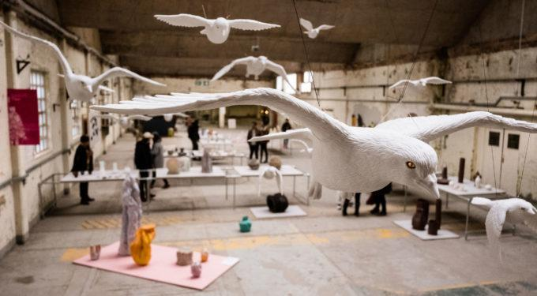
We understand the paragraph above isn’t holistically reflective of the rich community in which we live and work and if you don’t feel this speaks to you and you would like to support how we communicate this in future please get in touch with us:
info@britishceramicsbiennial.com

Questions and Answers
We have compiled a number of questions and answers to help with your application process. However, if any of the explanations below don’t answer your question or situation please email your question through: access@britishceramicsbiennial.com

Is there any access support available for artists wishing to apply who require additional support in order to do so?
Yes. If you feel that you need access support a BCB team member is available to help with your application. Please email: access@britishceramicsbiennial.com to discuss how we can help you.
If you would prefer to, you can also submit your application as an audio or video recording in the application form. In the application form where indicated please share a link to your audio or video file (this can be shared as a link from: dropbox, google drive, vimeo or youtube for example).

What is continued engagement in practice, including time learning or in education? And how do I demonstrate this?

Being ‘continually engaged in practice’ is to have an ongoing commitment to developing your creative work over a period of time. For example, you might have been studying or training and are now continuing independently. Or, you might have worked with a collective or studio and wish to profile your activities through the exhibition.

How do you define an early career artist?
We define an early career artist as someone who has been practicing between 3 – 7 years, including time in education or learning.

How can you identify when I have been practicing for 3 years?
The beginning of sustained engagement in learning or education can act as a marker for the beginning of your practice.
For example:
- The end of the first year of a BA degree can mark year one of your practice.
- The end of the first year you started taking workshops/classes to deepen your passion for learning ceramics can mark year one of your practice.
- The end of the first year of your apprenticeship can also mark year one of your practice.

How do you define quality?
We define quality as the balance of artistic intention, the ability to realise and deliver on those intentions in physical form and to effectively communicate them with an audience.

Can the works I apply with be made with materials other than clay?
Yes, providing the primary medium is clay.

How do we define socially engaged clay practice?
“Socially engaged practice describes art that is collaborative, often participatory and involves people as the medium or material of the work.” (quote from TATE). Socially engaged clay practice will also place clay/ceramics at the centre of this engagement.

Can I propose new work?
No — only existing work up to 3 years old is eligible for Fresh 2021.

Is there a size restriction?
No, not at this stage — but please provide dimensions of all work submitted in the title of your image files or application.

What media are eligible for entry?
All media are eligible providing the ‘primary medium is clay’.

Can I apply if I have been selected for previous Fresh exhibitions?
Yes as long as you are still within 3-7 years of practicing.

How do I send my application?
Please complete the following items as part of your application for Fresh 2021:
- Step 1 Please read or listen through the Application Guidelines
- Step 2 Complete the Fresh Application Form
- Step 3 Select up to 6 supporting files
- Step 4 Fill out your Diversity and Equality monitoring form.
- Step 5 Submit your application form and supporting files
- Step 6 Finally Complete and submit Applicant Details

I’m having a problem accessing/sending my application! What do I do?
Please contact, email: access@britishceramicsbiennial.com we are happy to help. Due to high quantities of applications being made leading up to the deadline we strongly advise that you make and send in your application well in advance of the deadline.

