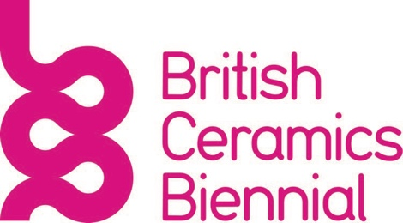

ReCast Film Brief

Project Background and Objectives

ReCast is a creative and social programme between the British Ceramics Biennial (BCB) and Stoke Recovery Service. It involves working with clay to explore connections with recovery. ReCast forms part of a 3-month intensive abstinence-based recovery programme with Stoke Recovery Service and is part of BCB’s year-round Community programme.
There are three cohorts that each take part in an 8-week programme of clay workshops at Stoke Recovery Service. At the end of the three programmes, all the participants are invited to take part in a residency at the BCB studio. The residency lasts for four days over two weeks in March 2023 (14th and 15th March and 21st and 22nd March 2023). The structure of the residency involves making and decorating in the first week and raku firing and reflective activities in the second week.
The aim of this film commission is to produce a film about the ReCast programme with a focus on the residency. We would like it to present the making and material explorations of the residency as well as processes such as the firing. The film should also reflect BCB’s vision and mission as below. We would like it to incorporate interviews with the programme’s lead artist, staff from Stoke Recovery Service and interviews or voiceovers from participants. We would like the participants to respond to questions such as:

What did you make?
What did you enjoy doing?
Did you learn anything new?
Are there any connections you have found between working with clay and your recovery journey?

Target Audience
Museum and gallery partnerships, academics, socially progressive funders and professionals, other artists, BCB stakeholders and local authority stakeholders.

Key Message(s)
The impact of working creatively with clay on addiction recovery.

With the underlying message in line with:
Our Vision – Making change through clay.
Our Mission – To develop, sustain and expand innovative ceramics practice and improve lives together with artists and creative communities.

Specifications and Distribution

Main film
7–10-minute film
16:9 (suitable for projection and online)
- Online: The film will be presented on the BCB website via our BCB Player (hosted through YouTube)
- Exhibition: The film will be presented in a stand-alone exhibition at AirSpace Gallery in Hanley (9 – 20 May 2023 alongside the work made over the whole programme, photographic and audio documentation. The film will also be presented as part of the BCB Festival 2023 (23 September – 5 November)

Social media teaser video
Distributed on BCB’s social media channels (Instagram/TikTok)
- Up to 90 secs long
- Formatted versions for both channels

Tone of Voice
The tone of the film should be professional and sensitive.

Mandatory Elements
To work alongside Joanne Mills and the project team to ensure that participants are interviewed and filmed in a way that respects their dignity, choices, and safety, following safeguarding procedures. We will provide you with a copy of the BCB Safeguarding Adults Policy.

Use BCB branding (we will supply you with our brand guidelines, BCB font and logo sting)
Include subtitles for the film and teaser in a clear contrasting colour.
Include funding and partnership logos in the credits:
- British Ceramic Biennial
- Stoke Recovery Service
- Arts Council England
- The Rayne Foundation
- The Community Foundation for Staffordshire
- Staffordshire University
- AirSpace Gallery

Timeline and Location

Contract begins: 1 March 2023
Beginning of March 2023: Liaise with Jo Mills about the approach to filming
Filming dates: 14th,15th, 21st & 22nd March
Location: BCB Studio, Spode Works, Elenora Street, ST4 1QQ
First Cut: 13 April 2023
Deadline for film sign-off: 9th May 2023

Budget
£3000 one-off fee inclusive of travel and expenses.

Approval Process
The film will go for initial approval by Joanne Mills and Gabriella Rhodes (Marketing and Communications Manager).
Final sign-off from the Artistic Director and CEO, Clare Wood.

Copyright
The copyright of the idea and work produced shall remain the property of the Artist. However, the artist agrees to provide BCB with an in-perpetuity license to broadcast/exhibit the work on a global basis and use the work and images of the work in communicating the work to the public and in making the work available to the public.

