Evaluation Consultant Brief (Transferer project)

Background

The Clay Foundation is a Charitable Incorporated Organisation trading as the British Ceramics Biennial or BCB.

Vision: | Making change through clay
Mission: | To develop, sustain & expand innovative ceramics practice and improve lives together with artists and creative communities.
Values: | To be bold, accountable, grounded, inclusive, welcoming, connected, significant and collaborative.

The vision, mission and values, known as BCB’s core purpose, was developed through discussion and exploration with the BCB Board of Trustees, staff and Advisory Network. The final version was ratified by the Board, with each trustee committed to ensuring the core purpose is reflected in all of BCB’s work and the values inform BCB’s strategy and performance monitoring.

BCB was born out of a strategic partnership with the City of Stoke-on-Trent Council to celebrate Stoke-on-Trent’s heritage and explore the potential of ceramic-led cultural regeneration. BCB is now an independent charity that sits at the heart of cultural delivery in Stoke-on-Trent. We deliver a biennial festival and year-round programme, enabling thousands of people each year to engage in the creative, social and health related benefits of clay.

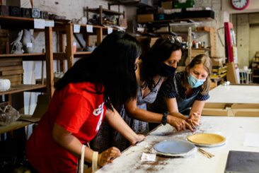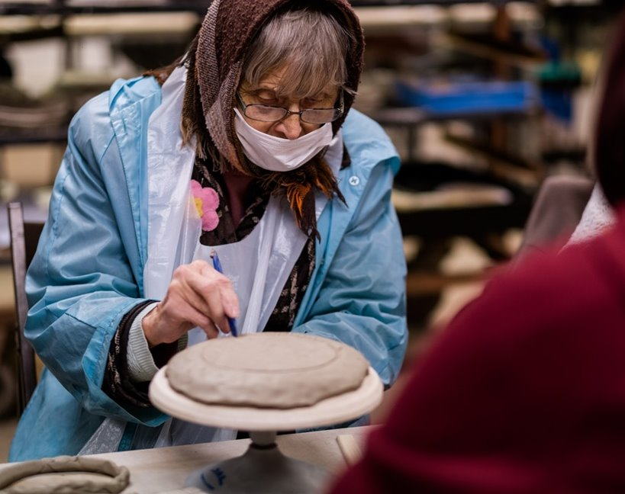

Building upon the Council’s vision for ceramic-led cultural delivery, BCB has grown and prospered. BCB joined the Arts Council National Portfolio in 2018, the same year BCB won the national Best Family Event Award from the Family Arts Campaign. BCB has now delivered seven BCB festivals - most recently in autumn 2021 & next in autumn 2023. The BCB festival is the UK’s largest contemporary ceramics event. The seven BCB festivals to date have welcomed over 270,000 visits with thousands more people engaging digitally & via media coverage. The festivals have generated over £8.3m of value in positive media coverage & produced economic activity in excess of £9.2m.

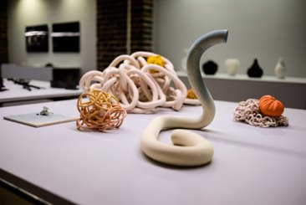
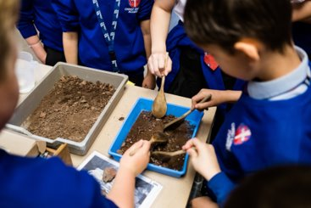

Transferer Project Overview

Transferer is an innovative project that explores cross-curricular approaches to art-based learning funded by Paul Hamlyn Foundation’s Arts-Based Learning Fund. This 18-month programme develops the learning and success of the Fresh Youth Panel, which was an initiative in which young people informed the selection of Fresh exhibitors for the 2021 BCB festival.

Transferer will engage students within the community. They will work with clay, talk about art and create their own exhibition spaces. As a result, we will support improvement in their oracy and critical thinking and will build confidence and key transferable skills. Groups from partner schools in Stoke-on-Trent will take part in weekly artist-led sessions. They will reflect on their thoughts and experiences in order to build their confidence in critiquing artworks. Their learning and evaluation will shape the progress and delivery of the project.

Transferer will centre the voices of young people within BCB. This will build their confidence to express themselves and their ideas. Working with young people in Stoke-on-Trent is central to our work, reflecting our values of being inclusive, welcoming and collaborative. We recognise how vital engagement with the arts is for young people to expand their cultural horizons.

Paul Hamlyn Foundation Arts-based Learning Fund

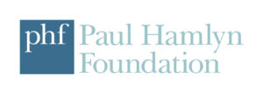
Transferer is funded by Paul Hamlyn Foundation as part of their Arts-based Learning Fund. This fund supports work which enables pupils in formal education settings, particularly those experiencing systemic inequality or disadvantage, to thrive through engagement with high quality, arts-based learning.
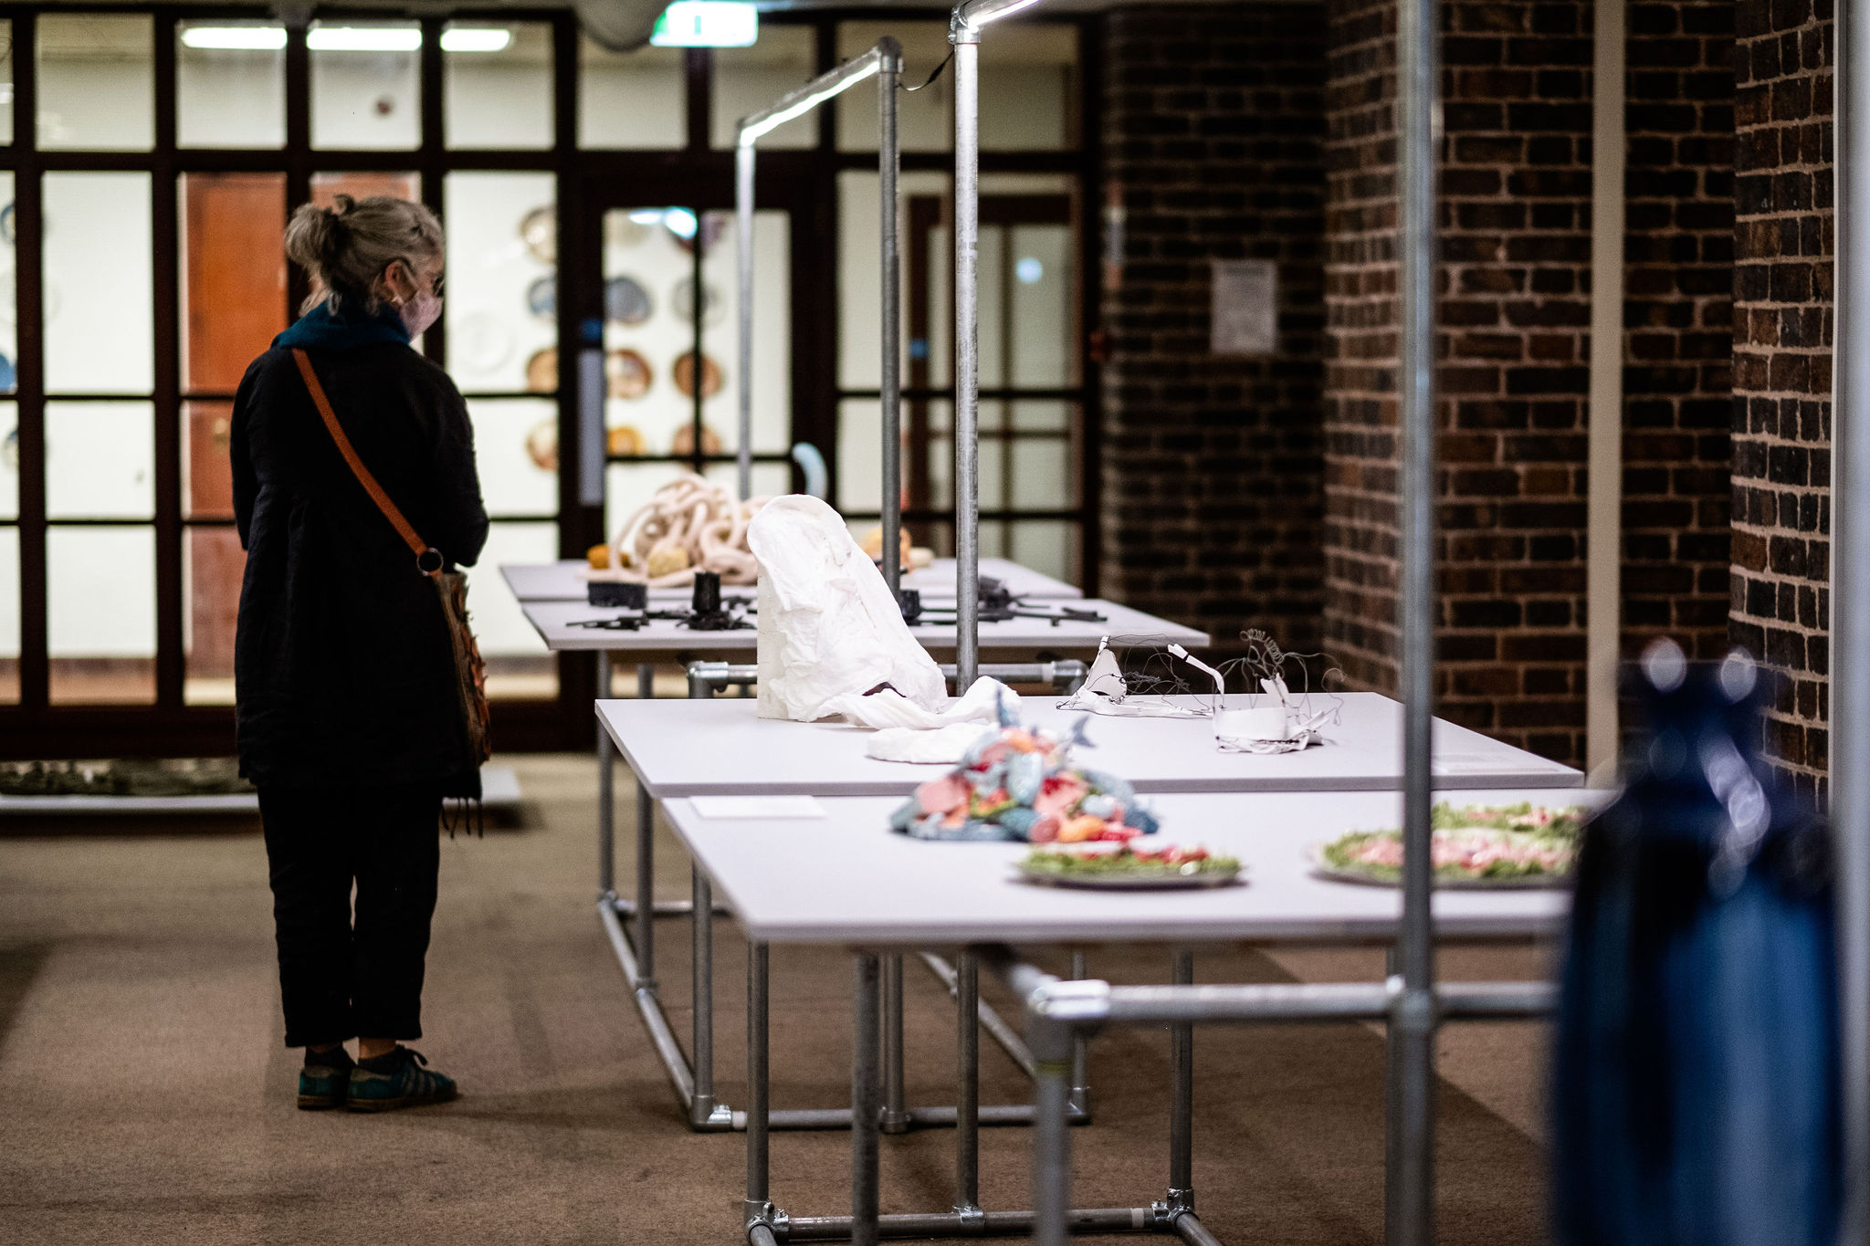
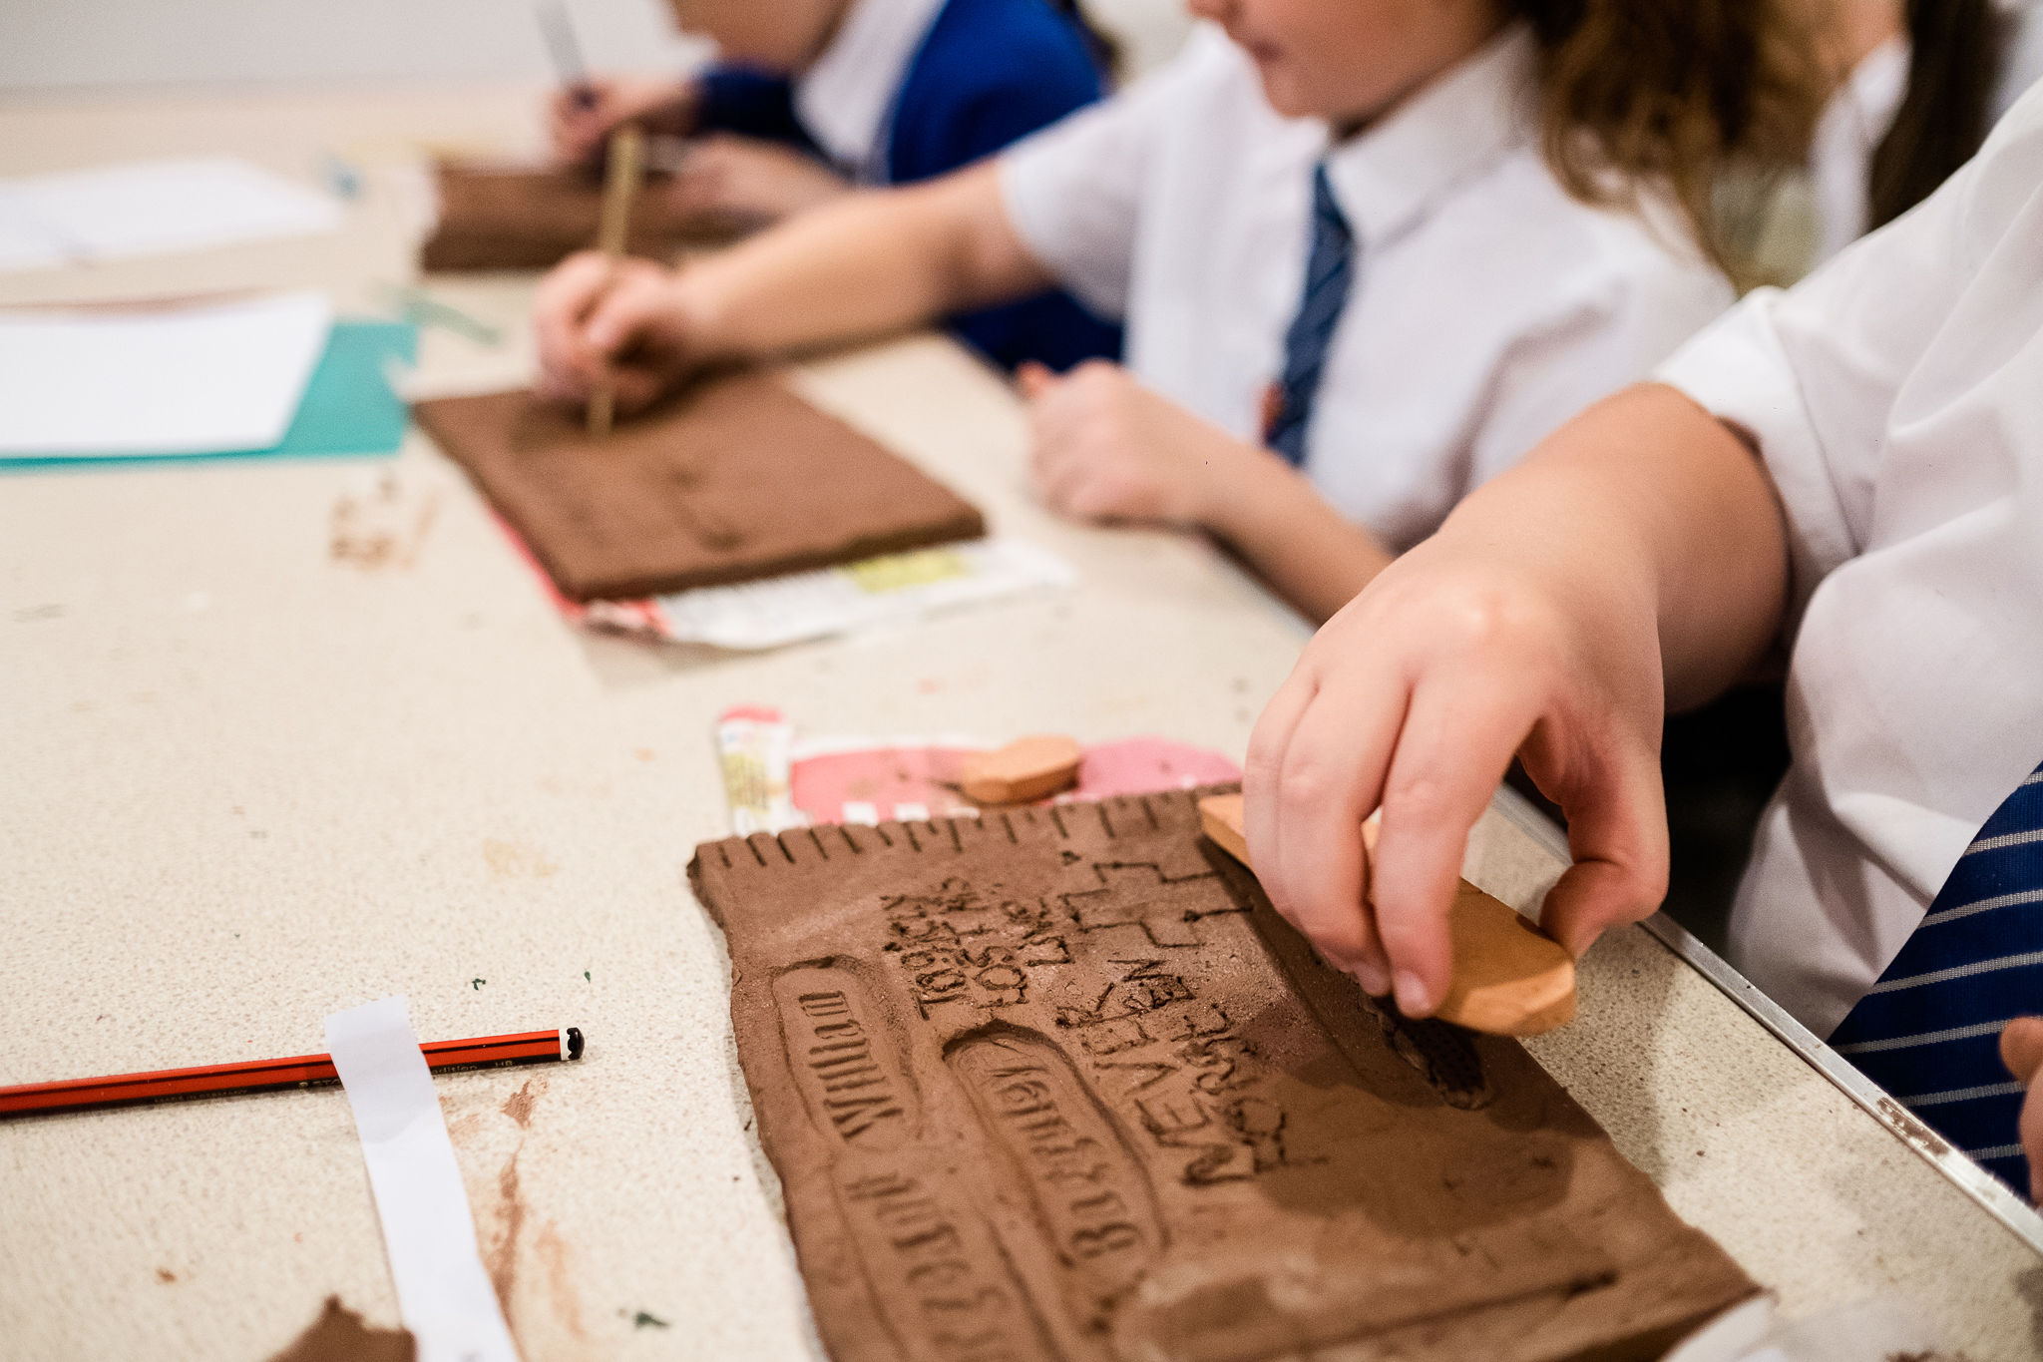

Transferer Evaluation Brief

We are seeking a skilled creative evaluator to work with us to evaluate the impact of the project. Working with the BCB Learning and Participation Manager and the Transferer Project Co-ordinator, the evaluation will seek to explore these key areas and potential project outcomes:

Students
- Improvement in oracy and critical thinking skills
- Well-being during the project sessions – for example, do they feel included and find the sessions accessible
- Improvements in school outcomes, such as better engagement and attainment in subjects such as English
- Developing confidence and other skills through collaboration and co-creation with artists and BCB
Teachers
- Improved understanding of the benefits of oracy and development of critical thinking skills
- Development of toolkit to help teachers improve oracy and critical thinking development in classroom environments

Delivery period
June 2023 to October 2024
(Final report to Paul Hamlyn Foundation is due on 18th October 2024)

Fee
£4,500 (inclusive of VAT, travel and expenses)

Applications
Please submit the following by 12pm Friday 9th June 2023
- Evaluation Budget: an outline of how you would envision the expenditure of £4,500 fee
- Outline plan with and indication of how you would approach the work, including how workload would be spread across the duration of the project
- Details of relevant knowledge, skills and experience
- CVs of key personnel to be involved with the project
- Contact details for two referees

Applications should be addressed to Natalie Armitage and sent via email: natalie@britishceramicsbiennial.com with Transferer Evaluation Proposal in the subject line by 12pm Friday 9th June 2023
For an informal conversation prior to applying, please email natalie@britishceramicsbiennial.com or call 07597 256038

Projected Timeline
The closing date for receipt of proposals: 12pm Friday 9th June 2023
Shortlisting notification by: Friday 16th June
Interviews: to take place week of 19th June
Successful applicant/organisation notified and contracted by: Monday 26th June
Delivery from: 5th July 2024
Completion by 18th October 2024

