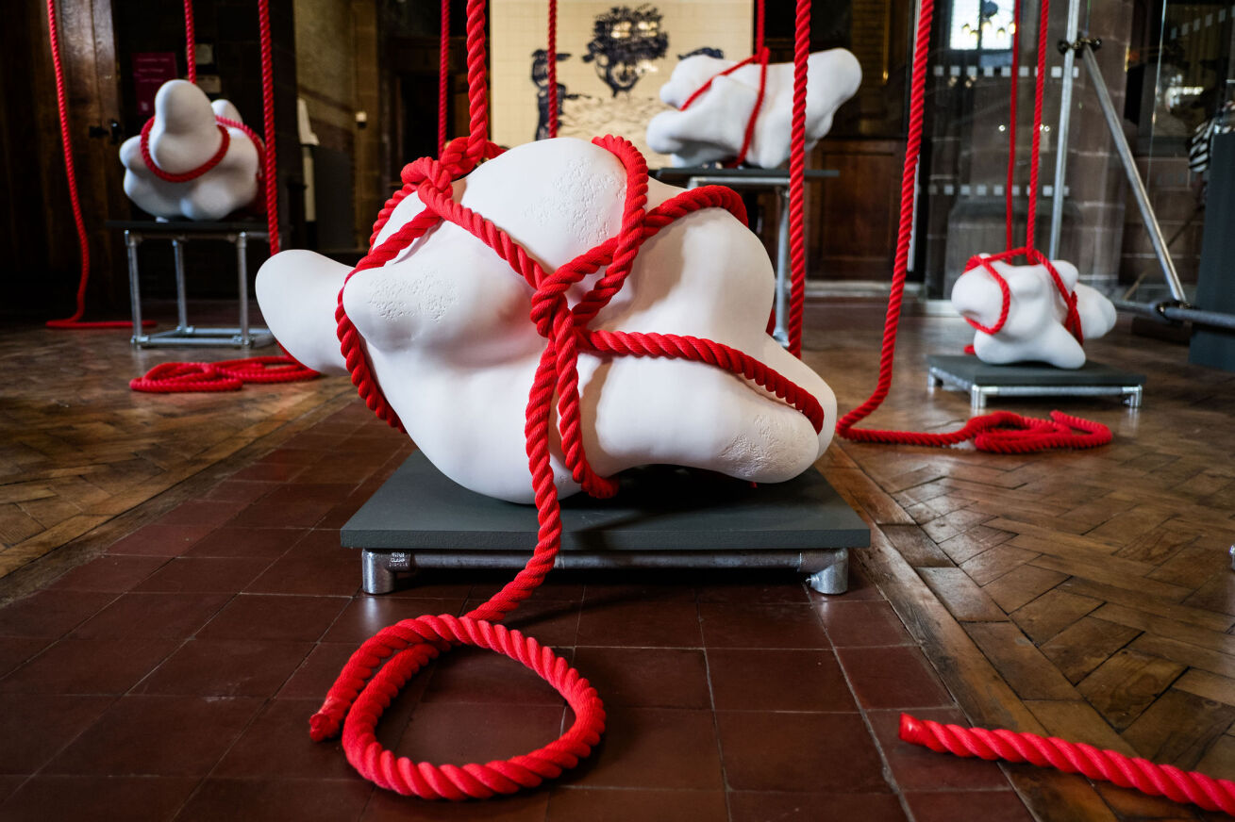
Sounding Line by Award 2023 winner Mella Shaw. Photo credit Jenny Harper

Award 2025

Presented as the centrepiece of the British Ceramics Biennial, taking place in Stoke-on-Trent in summer/autumn 2025.

Application Deadline: 12 noon, 9 September 2024

Award 2025 Application Guidelines

Contents

Pg 3 What is Award?
Pg 3 What are the ambitions of Award?
Pg 3-4 Who is Award for?
Pg 4 What do the shortlisted artists receive?
Pg 4 What is expected from the short-listed applicants?
Pg 4-5 Who is eligible?
Pg 5 Award 2025 selection panel
Pg 5 The selection criteria
Pg 6 Diversity and inclusion
Pg 6 Key dates Award 2025
Pg 6-7 Access support
Pg 7-8 Audio application guidelines
Pg 8 How to apply
Pg 9-11 Application guidance
Pg 12-14 Frequently asked questions

What is Award?

“Award offers a space for artists to build upon their expertise to say something new. As the UK’s leading exhibition of contemporary ceramics and clay, we seek to make experimentation, risk taking and ambition central to Award. The abundant ways of working with clay make it an extraordinary material for sharing ideas, provocation, storytelling and activism. For this headline exhibition of the British Ceramics Biennial, we welcome those with established artistic careers to explore and expand the boundaries of their practice.”
Clare Wood, Artistic Director & Chief Executive, British Ceramics Biennial & Award Panel Member

Award is the British Ceramics Biennial’s headline exhibition. Award celebrates the vitality of contemporary ceramics practice in the UK with ten artists selected from an open submission process.
A panel of experts who are integral to the growth and innovation of contemporary ceramics practice select ten artists to exhibit in BCB 2025. Each selected artist will receive £1,000 towards the presentation of their work as a central component of the Biennial. From the selected artists, one winner is announced and awarded a £10,000 cash prize during the Biennial.

What are the ambitions of Award?
- To present ambition and creative risk-taking within contemporary ceramics
- To celebrate the talent and achievements of artists
- To give a platform to artists with a compelling idea or opinion they want to express
- To be diverse and inclusive, reflecting the richness of ceramics practice

Who is Award for?
Award invites applications from UK-based individual practitioners, collaborators or collectives who use clay as their primary material. The Award exhibition seeks to have a positive impact on the practice of the exhibiting artists. We seek to support artists who want to make best use of the opportunity, who may wish to tread new ground, use the momentum of the exhibition to focus or make a step change in their practice or to present work in ways it hasn’t previously been experienced.

What do the shortlisted artists receive?
Each of the ten selected artists will receive £1,000 towards the exhibition of their selected work as part of the Award exhibition at the 2025 Biennial. Award exhibitors will benefit from a national PR and marketing campaign, curatorial support, programme management support and return transport of exhibits. The Award winner will receive a cash prize of £10,000 and a place on the 2027 Award selection panel. They will be invited to exhibit at BCB 2027 and will benefit from additional marketing.

What is expected from the shortlisted artists?
Artists apply for Award by submitting a proposal, which outlines what they wish to exhibit. The artists selected must produce the work in line with their proposal. The £1,000 fee is provided to facilitate the production of the agreed work. We recognise that artists may wish to propose work that will require them to secure additional funding or resource to realise their proposal.
It is understood that the proposal may change through the creative process. Any changes should be discussed with BCB. The artists should budget for transporting the work to the BCB exhibition site. Artists are responsible for installing and deinstalling their own exhibit. Reasonable practical support from the BCB team will be provided where possible.

Who is eligible?
Artists applying for Award should meet the following three criteria.

- Be based in the UK between September 2022 and August 2025.
- Working professionally as an individual artist or collective since September 2022. Artists working in collaboration are also eligible. A collaboration may take place between an artist and arts organisation, between artists or between an artist and community group in the creation of the proposed exhibit.
- Propose work that uses clay as the primary medium and is based on the exploration of ceramic process. Areas of practice may include, but not be limited to studio pottery, design, socially engaged practice, sculpture, performance, installation, objects, film and audio.
Please note:
- Previous Award exhibitors are eligible.
- Students in education at the time of applying are not eligible. This includes BA and MA students or equivalent.
- Those undertaking postgraduate research work leading to a PhD/Mphil/MLitt/MRes or equivalent are eligible.
If you have any questions regarding eligibility, please get in touch: apply@britishceramicsbiennial.com

Award 2025 selection panel
Award exhibitors are selected by a panel of leading professionals who are advocates for contemporary art and making, and who bring a variety of perspectives to the decision-making process. The Award 2025 selection panel will be announced in due course on the BCB website.

The selection criteria
- The quality of the idea and proposal
- The quality, strength and ambition of the artistic practice
- The potential impact of the proposal on the development of the artists’ practice
- The potential for the work to connect with audiences

Diversity and inclusion
We recognise that there is a lack of diversity in the ceramics sector. As an organisation we share responsibility in addressing systemic inequalities by increasing representation of diverse artists and practice in our Biennial, exhibitions and events programmes.
We are undertaking our responsibility to address under-representation and remove barriers in accessing opportunities through adapting our systems, improving our communications and expanding our networks. We aim for our actions to lead to an increase in applications from artists who feel their identity and background are currently under-represented. We welcome conversations with anyone with ideas and networks that can help progress this work more quickly.

Key dates for Award 2025
26 April 2024 Applications open
9 September 2024 Deadline for submissions (12noon GMT)
October 2024 Award selection panel meet and candidates informed
Nov/Dec 2024 Studio visits for selected artists
Aug/Sept 2025 Delivery of work to exhibition venue and installation
September 2025 Biennial launch - Award exhibition opens to the public
Sept/Oct 2025 Award winner is announced

November 2025 Award exhibition closes to the public and collection of work

Access support
Access support is available to individuals who feel they face barriers in making an application. A BCB team member is available to help with your application or to offer advice in advance of your application. Please email apply@britishceramicsbiennial.com to discuss how we can help you. Alternative formats are available upon request to ensure they are suitably tailored to support an applicant’s access requirements.
Please note that the advice we give on making an application is on the eligibility and suitability of your proposal, it will have no bearing on its assessment during the selection process.

Audio application guidelines
We have recorded the Award 2025 application guidelines, please click here to listen.

Audio or video proposal submissions
You can submit your application proposal as a six-minute audio or video file. If you are submitting an audio or video recording of your Award proposal, you will need to clearly separate each of the three sections:
- Artist statement – 200 words
- Proposal – 500 words
- Environmental impact statement- 200 words
You can do this by speaking aloud or through post-video editing. Please include the proposal questions in the recording as a guide.
If you require further assistance, a BCB team member can assist you with the Award proposal. We will prompt you with each section and ask you the proposal questions and record your proposal on Zoom for your application. Please email apply@britishceramicsbiennial.com if there is anything we can do to support you. Please note that the BCB team will only ask questions as they are written in the application form, we will not be offering further advice or asking for clarification from you. Using this method for your application will have no bearing on its assessment during the selection process.

Submitting an audio or video proposal submission
In the proposal section of the application form please share a link to your audio or video file (this can be shared as a link from: Dropbox, Google Drive, Vimeo or YouTube for example). The recording of your proposal should be clear and not heavily produced. There will be no assessment of the production quality of audio or video recordings. Please ensure the audio or video length is no longer than six minutes. You will still need to fill out the application form on our website to submit your contact information, budget and timeline. If BCB can transcribe this information for you, please email apply@britishceramicsbiennial.com.

How to apply
Artists are asked to submit an Award proposal outlining the work they propose to make if selected.
This will include:
- Artist statement – 200 words
- Proposal – 500 words
- Environmental impact statement- 200 words

Application Items | How do I submit this item?
The application form | Fill out the application form on the BCB website
The Award proposal
- Artist statement
- Proposal
- Environmental impact statement
Up to 8 supporting files | Images included in your supporting files must be no more than three years old and cannot include graduate or student work.
Budget and timeline | [Click here to use the spreadsheet templates]
Diversity & Equality Monitoring Form | [Click Here to complete the form]

Application guidance
The application form
The application form is available on the BCB website. If you are writing your Award proposal, we advise that you write your artist statement, proposal, and environmental impact statement on a separate document, as it will be easier for you to edit and proofread. You can then copy and paste to the form once you are ready.
Your proposal will be saved and stored in your browser in case you lose connection or need to pause. Please do not close the browser if you want to keep your information stored.
The Award proposal
- Artist statement (200 words)
  - This is a general statement about how you work as an artist. It should give an overall view of your current artistic practice.
- Proposal (500 words)
  - Please answer these questions in your proposal:
    - What is your idea for Award?
    - How will it look and how will you make it?
    - Why is it important for the work to be presented now?
    - How will the work extend and develop your practice as an artist?
- Environmental impact statement (200 words)
  - Please list the sustainability practices you are committed to or will commit to in your proposal for Award. BCB seeks to responsibly manage its environmental impact and therefore all artists we work with are asked to outline their environmental responsibility actions and consider new actions they can take. Applicants who do not provide methods they seek to implement in being environmentally responsible will not be considered.
Examples may include:
    - Committing to low or no firings
    - Recycling and reusing materials
    - Presenting work that engages with environmental themes
    - Using a green website host
    - Using renewable energy sources
If you submit an audio or video recording, please include each of the items in the Award proposal as well as the proposal questions in the recording. You can share a link to this file when prompted in the application form. See Audio or Video Proposal Submissions for further guidance.
Budget
Please list the costs involved in your proposal, income identified and if necessary, please indicate unidentified income. We know that artists may wish to propose work that will require additional funding or resource, however, this is not an expectation of the exhibition.
Timeline
Please share with us how you see the proposal coming together starting from October 2024 please list key points and self-set deadlines demonstrating how you will meet the delivery deadline of August 2025.
Please use the Budget and Timeline template here.
Please format your spreadsheet title: yourname_BCBAward2025_Budget&Timeline
Supporting material
You will be able to submit 8 supporting files within your application
- Supporting files can include photographs of existing work, illustrations of your proposal or recordings of planned or existing work
- Files can be no larger than 5MB and should be 300 dpi. Please title your files with:
  - yourname_worktitle_year_dimensions_primarymaterialused
- File types accepted are: png, jpg, jpeg, wav, mp4
- Images included in your supporting files must be no more than three years old and cannot include graduate or student work.
Applicants must also complete the online Diversity and Equality Monitoring Form.
The information collected through this form will be used to provide a demographic profile of artists working with BCB, allowing us to address under-representation and remove barriers in accessing opportunities. We aim to increase applications from artists who feel their identity and background are currently under-represented.

Frequently asked questions
How do you define quality?
We define quality as the balance of artistic intention, the ability to realise and deliver on those intentions in physical form and to effectively communicate them with an audience.

What do you mean when you speak about creative risk taking?
We describe creative risk taking as a mixture of innovation and boldness to do something new.

Can the works I apply with be made with materials other than clay?
Yes, providing the primary medium is clay and the work is based on the exploration of ceramic process.

Do the images I submit in my supporting files need to be new work?
No — you can submit images in your supporting files of work up to three years old, excluding graduate and student work.

Is there a size restriction?
No, not at this stage — but please provide dimensions of all work submitted in the application form.

What media are eligible for entry?
All media are eligible providing the primary medium is clay and the work is based on the exploration of ceramic process.

Can I apply if I have been selected for previous Award exhibitions?
Yes.

I work as an in-house designer for a ceramics company. Can I apply as an individual?
Yes, with the permission of your employer and providing that you are the credited designer of the work submitted.

What should I include in my budget?
Your budget should include the costs involved in making and installing your work, transport of work to the exhibition site, your travel costs and any other expenses you see as connected with the proposed exhibit. Please also include any income/funds you have towards the cost of the work or funds you will apply for if selected.

I’m having a problem accessing/sending my application. What do I do?
Please email apply@britishceramicsbiennial.com. We are happy to help. Due to high quantities of applications being made leading up to the deadline we strongly advise that you make and send in your application well in advance of the deadline.

Is there any access support available for artists wishing to apply who require additional support?
Yes. If you feel that you need access support, a BCB team member is available to help with your application. Please email apply@britishceramicsbiennial.com to discuss how we can help you.
You can also submit your application as an audio or video recording. In the application form, where indicated, please share a link to your audio or video file (this can be shared as a link from: Dropbox, Google Drive, Vimeo or YouTube for example).

Who has exhibited in AWARD?
2023 - Carrie Reichardt, Copper Sounds, Dan Kelly, Elspeth Owen, Jasmine Simpson, Mella Shaw, Nicola Tassie, Ranti Bam, Rebecca Appleby and Rebecca Griffiths.
2021 - Alison Cooke, Christie Brown, Cleo Mussi, Connor Coulston, Tamsin van Essen, Helen Beard, Ho Lai, Jin Eui Kim, Mawuena Kattah and Stephen Dixon.
2019 - Zoe Preece, Jessica Harrison, Sam Lucas, Irina Razumovskaya, Elliott Denny, Adam Buick, Hannah Tounsend, John Rainey, Barry Finan and Vicky Lindo & William Brookes.
2017 - Eva Masterman, Katie Spragg, Malena Hartman Rasmussen, Matt Smith, Matt Raw, Nicholas Rena, Pauliina Pöllänen, Tana West, Zoe Lloyd and Alex Simpson.
2015 - Sam Bakewell, Anne Gibs, Amy Hughes, Bethan Lloyd Worthington, Ingrid Murphy & Jon Pigott, Aneta Regel, James Rigler, Mella Shaw, Caroline Tatterstall and Andrea Walsh.
2013 - Christie Brown, Matthew Chambers, Claudia Clare, Zachary Eastwood-Bloom, Edith Garcia, Malene Hartman Rasmussen, Ikuko Iwamoto, Johnathon Keep, Kim Jin Eui, Nicholas Lees, Andrew Livingstone, Nao Matsunaga, Ian McIntyre, James Rigler, Lara Scobie, Louise Taylor, Tamsin Van Essen, Andrea Walsh, James and Tilla Waters, Katy West and Conor Wilson.
2011 - Carina Ciscato, Robert Cooper, Phoebe Cummings, Lowri Davies, Robert Dawson, Stephen Dixon, Ken Eastman, Philip Eglin, James Evans, Chris Keenan, Rob Kessler, Ikuko Iwamoto & Kazu Loudor, Sun Kim, Peter Lewis, Nao Matsunaga, Craig Mitchell, Katharine Morling, Rosa Nguyen, Merete Rasmussen, Angela Speight, Julian Stair, Caroline Tattersall, Andrea Walsh and Dawn Youll.
2009 - Ikuko Iwamoto, Ingrid Ruegemer, Louisa Taylor, The New English - Designer: Marcus Steel, Lisa Turner, Monica Tsang, Florian Hutter, Terrie McGettigan, Tanja Livingstone, Lucy Whiting, Sam Bakewell, Neil Brownsword, Halima Cassell, Phoebe Cummings, Natasha Daintry, Stephen Dixon, Philip Eglin, Catrin Howell, Aimee Lax, David Roberts, Fran Priest, Paul Scott, Jacob van der Beugel, Conor Wilson and Dawn Youll.

