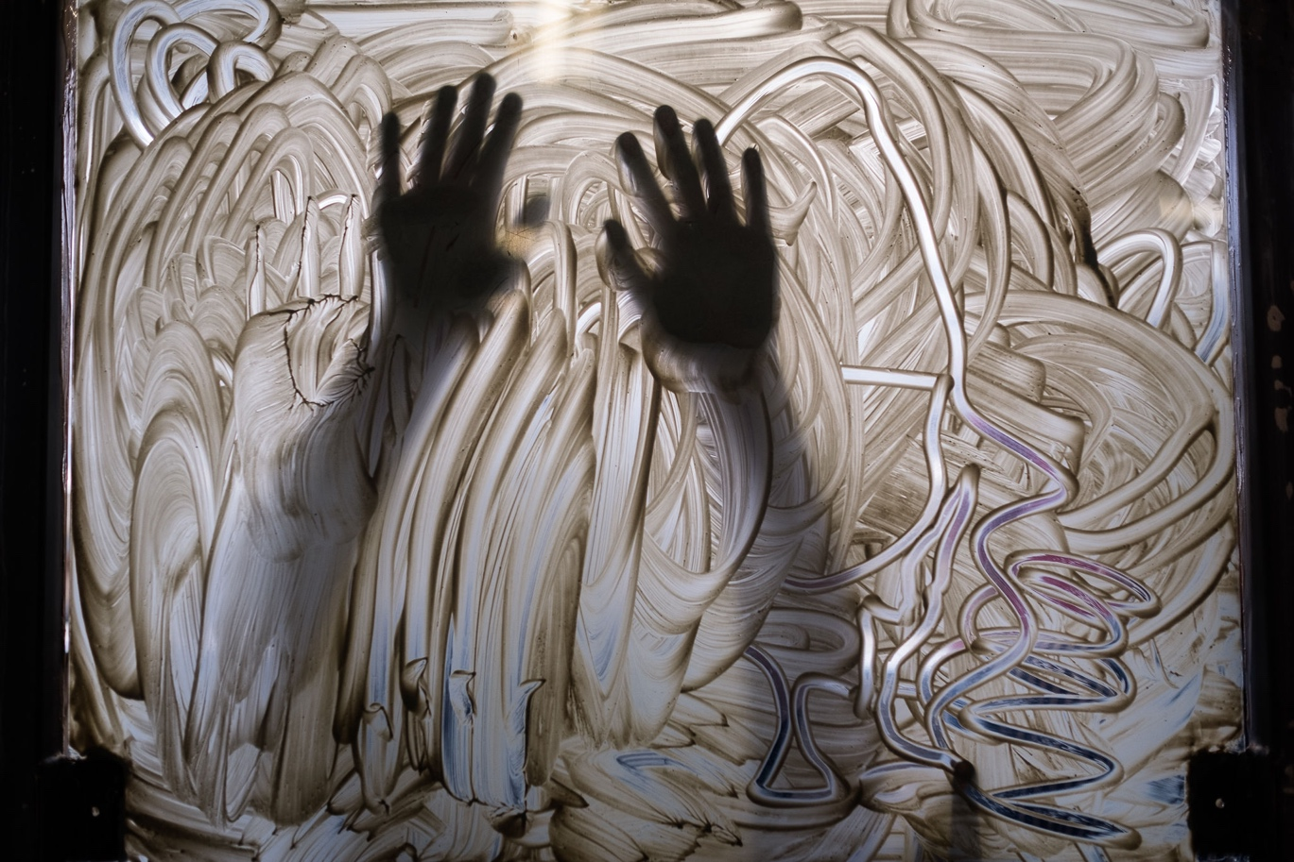
Clay Films 2025 Application Guidelines
Artists working with film and moving image are invited to apply for the 2025 British Ceramics Biennial Clay Films programme, taking place in Stoke-on-Trent, UK from 6 September to 19 October 2025.

Deadline for applications: 24 June 2025

Contents
About Clay Films 2
Eligibility 2
Submission criteria 3
Selected artist fee 3
Expectations for selected artists 3
Clay Films selection criteria 3
Key dates for Clay Films 2025 4
How to apply 4
Access support 5
Frequently asked questions 6

Clay Films call for artists
Clay Films celebrates the medium of clay and the artists who capture the vitality of this material with film.

This programme is open to Global Majority artists of African and Caribbean heritage based throughout the world and invites them to submit an existing short film for consideration.

Ten films will be selected and showcased at the 2025 British Ceramics Biennial.

Deadline for applications: 24 June 2025

About Clay Films
The Clay Films project will celebrate and increase the profile of Global Majority artists who are working with film and clay as a primary material. We aim to reflect the richness of clay as a medium of artistic expression in film. We are interested in how artists are using film for storytelling, activism, provocation and exploration of identity. This can be in any film style or genre. We are seeking films which are intended to be artistic work, rather than filmed documentation or interpretation of other clay and ceramic artwork.

Clay Films is open to Global Majority artists of African and Caribbean heritage based throughout the world, including the UK. We invite these artists to submit an existing artist film for consideration. Submissions will be reviewed by a panel that includes Global Majority sector experts who will select ten films to be shown throughout the six weeks of the 2025 British Ceramics Biennial, taking place in Stoke-on-Trent, UK.

Eligibility
To apply for Clay Films 2025 you must be a Global Majority artist of African and Caribbean heritage over 18 years of age, working with the mediums of clay and film.

Submission criteria
Your short film may be of any genre, but must meet the following criteria:
- Maximum of 15 minutes in length
- Completed or re-edited in the last 5 years
- Original work of the submitting artist
- The submitting artist must have the copyright to the film and permission to use any soundtrack/music featured
- By submitting the film, the artist warrants that the film is original and does not infringe on any copyrights or rights of any person
- The film must be suitable for general viewing in a public space
- Resolution of 1080p or higher
- Any spoken language must be accompanied by English subtitles

Selected artist fee
Each of the ten exhibitors selected for Clay Films will receive a £350 presentation fee payment. Clay Films exhibitors will benefit from a national PR and marketing campaign.

Expectations for selected artists
Selected artists are responsible for sending the final high-resolution version of their film for screening and all exhibition-related copy for BCB 2025 by 31 July.

BCB will process a payment of £350 (GBP) value for all selected artists.

BCB is not responsible for international banking transaction fees and therefore artists based outside of the UK might receive less than £350 (GBP) value once banking fees are applied.

Clay Films selection criteria
All submissions will be reviewed by a panel that includes Global Majority sector experts who are advocates for contemporary art, moving image and making. These experts bring a variety of perspectives to the decision-making process. The panel will select ten short films that will be shown at BCB 2025, within a designated exhibition space created for screening the Clay Films programme.

The selection panel will consider the following criteria:
- High quality and ambition of the submitted work
- Visual impact and cinematography
- Storytelling

Key dates for Clay Films 2025
15 May | Application window opens
24 June | Deadline for submissions
By 25 July | Selection panel meet and candidates informed
31 July | Deadline for sending the final high-resolution version of their film for screening and all exhibition-related copy
6 September | Biennial opens to the public
19 October | Biennial closes to the public

How to apply
Artists are invited to apply for Clay Films by submitting their finished film, shot in high-quality format, via the FilmFreeway platform.
The film work submitted for exhibition must already exist and have been made or re-edited within the last 5 years, so your film should have been released in 2020 or later.

FilmFreeway submission guidance
Sign up for FREE on FilmFreeway platform following the instructions. Find out more about FilmFreeway.

Step 1: Create an account on the Film Freeway website: Film Festivals, Screenplay Contests, Submissions - FilmFreeway

Step 2: Add a Project
- Project information including
  - Type: film/video
  - Project title
  - Brief synopsis
  - Website and social media handles
- Submitter information
  - Contact information including your address, date of birth and gender
- Credits
  - Directors, writers, producers and key cast if applicable
  - Add your artist biography and statement on the Director information. This text will be used to write brochure and website content for BCB 2025 if you are selected
- Specifications
  - Project type, genres, runtime, completion date, country of origin and filming language, etc.
- Screenings / Distribution
  - Screenings, awards and distribution information, if applicable

Step 3: Link or upload your video
- Upload
  - Upload a high-quality video file, up to 10 GB
- Link
  - If your video is on Vimeo or YouTube, simply copy and paste the URL and password
Submit your films to the Clay Films 2025 submission page on FilmFreeway. Clay Films is free to enter. All films must be in their original language with English subtitles, when applicable.

If you are having trouble, please see the Help Center - FilmFreeway or take a screenshot of your issue and email apply@britishceramicsbiennial.com.

Step 4: Complete the Clay Films 2025 equality, diversity and inclusion monitoring form

Deadline for submission: 24 June 2025

Access support
Access support is available to individuals who feel they face barriers in making an application. A BCB team member is available to help with your application or to offer advice in advance of your application.

Any advice we give on applying is for the artists and film eligibility. It will have no bearing on its assessment during the selection panel. The office hours of BCB staff are 9am to 5pm British Summer Time. Due to the high volume of applications closer to the deadline there will be limited capacity for assistance after 18 June 2025.

If you have any questions about eligibility or access support, please contact apply@britishceramicsbiennial.com.

Frequently asked questions

Who is eligible?
To apply for Clay Films 2025 you must be:
- A Global Majority artist of African and Caribbean heritage living anywhere in the world
- 18 years or older
- Working with the mediums of clay and film

How do you define quality and ambition?
We define quality as the realisation and delivery of artistic intention in physical form and/or emotional and intellectual impact. We define ambition as the effort or ability by which artistic intentions are developed, planned and communicated. This information on ambition and quality from Arts Council England might also be useful (Essential read: Ambition & quality | Arts Council England)

Can I propose new work?
No, only existing films up to 5 years old are eligible for Clay Films programme.

Can I submit more than one film?
No, you can only submit one film and the film/moving image submitted must already exist and have been made or re-edited in the last five years.

How long can my film be?
Your film must be 15 minutes or shorter.

Does it have to be a finished film?
The film you submit will be shown as finished, there will not be any opportunity for further edits after your submission.

Can my film feature materials other than clay?
Yes, but the main focus and theme should be related to clay. Eligible work includes film/moving image/animation where ceramics or clay is a main feature.

What type of clay is acceptable as the main focus and theme of the film?
Your film should feature clay comprised of naturally formed clay minerals. We do not accept work featuring man-made polymer or modelling clays.

What type of film are you looking for?
We are interested in how artists are using film for storytelling, activism, provocation and exploration of identity. This can be in any film style or genre. We are seeking films which are intended to be artistic work, rather than filmed documentation or interpretation of other clay and ceramic artwork.

Can I submit a film in a language other than English?
Yes, but your film will need to include English subtitles.

I am having a problem submitting my film, what do I do?
Please contact FilmFreeway via their website: Contact Us - FilmFreeway or email support@filmfreeway.com during the following hours 9:00 a.m. – 5:00 p.m. PST (Pacific Standard Time).

You can also email apply@britishceramicsbiennial.com to get in contact with a member of BCB staff.

