2025 British Ceramics Biennial
Evaluation Brief

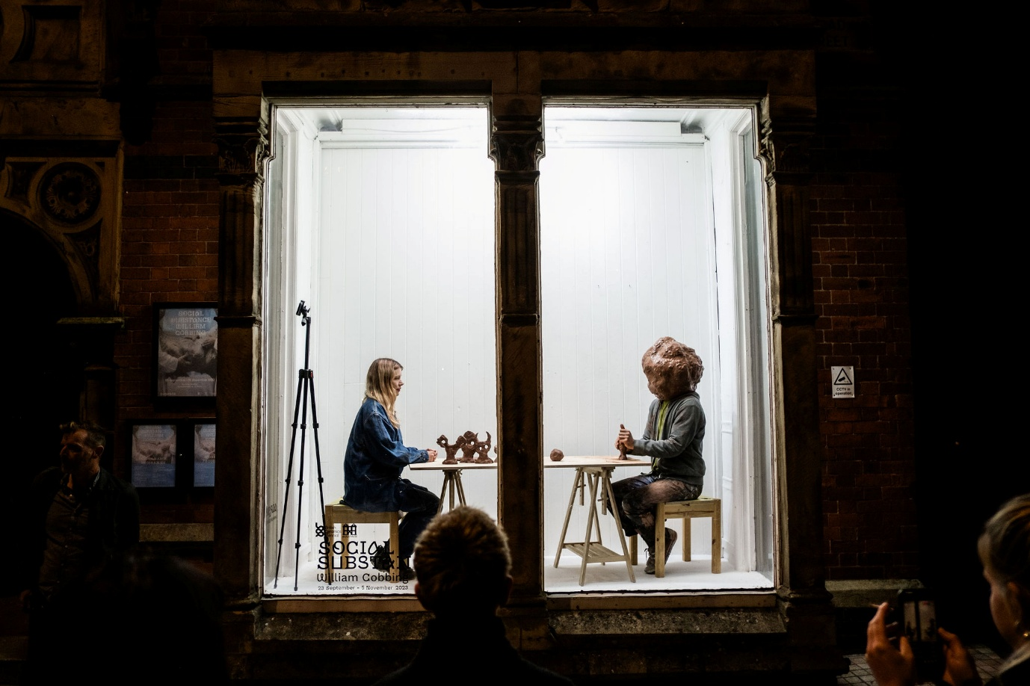
Photography: Jenny Harper

Introduction
The British Ceramics Biennial (BCB) is seeking to appoint an experienced project manager/evaluation expert to manage and deliver the evaluation of the 2025 Biennial in Stoke-on-Trent. From 6 September to 19 October 2025, BCB will present artworks from leading UK and international contemporary artists in exhibitions and special events held at Spode Works.
British Ceramics Biennial is the trading name for The Clay Foundation CIO, which is a charitable incorporated organisation and the legal entity that governs the activities of the British Ceramics Biennial.
Vision: Making change through clay
Mission: To develop, sustain and expand innovative ceramics practice and improve lives together with artists and creative communities
Values:

- Bold
- Accountable
- Welcoming
- Significant
- Grounded
- Inclusive
- Connected
- Collaborative

In delivering its mission, the 2025 British Ceramics Biennial will:
- Celebrate and promote contemporary British ceramics in the UK’s ceramics capital – building the profile of the British Ceramics Biennial as the national premiere contemporary ceramics event
- Create exciting opportunities where international and national artists can collaborate, research, develop and realise ambitious work and present new ideas in clay and ceramics
- Engage, inspire, entertain and inform local and national audiences, embedding within Stoke-on-Trent the potential for clay as an agent for learning, well-being and empowerment
- Secure the British Ceramics Biennial as an integral and leading organisation within the cultural infrastructure of the UK

For more information, please visit www.britishceramicsbiennial.com
Registered Charity Number: 116043

Background
BCB has been in existence since 2008. During this time, it has established itself as a key cultural agency in Stoke-on-Trent and has developed partnerships across many sectors, namely heritage; arts and culture; health and wellbeing; education and training; industry; private; public and charitable.
BCB was originally established as a high-profile regeneration project by Stoke-on-Trent City Council – a trailblazer for the city’s regeneration programme of transformation and renewal, proclaiming the city as the place where the best in ceramics is being designed, made and celebrated. Since 2018, BCB has been an Arts Council England National Portfolio Organisation.
BCB and its associated engagement activity and international programmes resonate across a number of the city’s strategic areas of focus. Over the past eight biennials, BCB has grown and developed its activities for visitors and residents alike. Stoke-on-Trent City Council investment, alongside that of Arts Council England, University of Staffordshire and varied public and private funding sources in the period 2009 to 2021, has resulted in:
- Welcoming over 300,000 visitors – with approximately 50% originating outside the city/ region and many visiting the city for the first time
- Generating over £9m of value in positive media coverage
- Producing economic activity in excess of £10.5m

Evaluation Brief
BCB is seeking evaluation of the 2025 Biennial programme based in Stoke-on-Trent. The scope of the brief includes development and implementation of evaluation methodology, management of data collection, and delivery of a final 2025 Biennial evaluation report. The design and delivery of the evaluation should be based upon BCB’s Impact Framework and Arts Council England’s Let’s Create Outcomes and Investment Principles. Biennial evaluation is expected to include a range of quantitative and qualitative data collection, including visitor surveys, artist surveys and participant interviews. Evaluation delivery expectations:
- Development of evaluation data collection methods (i.e. questionnaires, interview questions) to capture data in line with BCB Impact Framework and funder monitoring requirements
- Delivery of briefing session for BCB team and volunteers on evaluation to ensure consistent, accurate and appropriate data collection when interacting with Biennial visitors to collect survey responses
- Co-ordination with BCB duty team to collate data and manage audience surveys
- Oversight and management of data collected, to include a minimum of:
  - 1,000 responses to visitor survey
  - 35 responses to Biennial artist survey
  - Interviews with 15 visitors/community group representatives, 3 teachers, 2 course leaders/senior lecturers and 4 Biennial artists
- Co-ordinate with BCB communications team to collate and present information related to digital reach and engagement and media coverage
- Data collected to measure economic impact of Biennial programme (economic activity and economic impact) and travel data (distance and method)
- To ensure that all evaluation and data collection methods are designed and conducted in a way that seeks to achieve responses from a diverse range of people with a focus on accessibility and inclusion
- Delivery of an evaluation report that can be shared with stakeholders and on BCB’s website which includes:
  - Summary and key findings
  - Overview and analysis of data collected evaluating against 2025 Biennial outputs, outcomes and benefits for stakeholders (including city of Stoke-on-Trent, education, cultural and community stakeholders)
  - Digital communication reach and impact
  - Economic activity and impact
  - Audience data

Biennial Outputs and Outcomes

BCB Impact Framework Outputs
Exhibitions and presentations of work of artistic excellence | Material led-collaborative projects, exhibitions, events and services primarily in Stoke-on-Trent | Industry partnerships, thought-leadership, events and dissemination
Biennial Programme
- Award  - Fresh  - Fresh Talent  - People & Place Commission  - Raverina’s Dance Floor  - Clay Films  - Invitation  - University of Staffordshire Showcase | - Playscape  - Playscape Project Space  - Slip Tales  - Education visits  - Group tours | - Clay Conference  - Recovery and Clay event
- 66 x artists presenting work  - 10 x artist short films  - Opportunities created for artists from low socio-economic backgrounds  - 1 x launch event  - 1 x Award Prize evening event  - 1 x Award Prize winner  - 11 x in-person artist talks  - 4 x BCB Fresh Talent Prizes awarded  - 110 x social media posts | - 49,000 Biennial visits  - 18 x festival tours (targeted for public, community organisations & businesses)  - 1 x teacher CPD visit  - 6 x FE & HE workshop sessions  - 30 x school workshops sessions  - 700 hours of volunteering  - 10 x community interpretation texts (Award Voices) | - 100 event attendees  - 2 x thought leadership focused events  - Business partnerships established to improve Biennial offer

BCB Impact Framework Outcomes
Social | Artists and the sector benefit from creative development opportunities and networks | People and communities benefit from opportunities to collaborate, build understanding and improve wellbeing | Society and the economy benefit from expanded perspectives of clay
 | - Opportunities for artists created leading to career development, network building and enhanced artistic ambition | - People and communities have opportunity to participate in hands-on activities, experience events and take part | - Economic activity and impact: biennial visitors positively benefit the local economy
Organisational | Our artistic programme is internationally recognised for its creative ambition and as a catalyst for change | Our working methods are seen as best practice and enable the sharing of power and decision making | Our approach creates space for innovation and fosters collaborative opportunities with other leading practitioners
 | - Audience perception of exhibitions/events (creative ambition)  2 x stories of significant change | - Participant/audience perception of programming (socially engaged practice/collaborative working)  2 x stories of significant change | - Opportunities for collaboration and thought leadership created.  - Network building  2 x stories of significant change

Applications
Please submit an expression of interest by 10am on Monday 11 August consisting of the following:
- A covering letter detailing relevant experience
- A CV
- A fully costed proposal

Proposals should be addressed to Natalie Armitage and emailed to natalie@britishceramicsbiennial.com with ‘Evaluation Proposal’ in the subject line.
For an informal conversation prior to submitting a proposal, please contact:
Natalie Armitage, Head of Business Services, natalie@britishceramicsbiennial.com / 01782 294634

Timeline
Monday 11 August at 10am: closing date for receipt of proposals
13-18 August: Interviews with shortlisted candidates
By 19 August: Successful candidate contracted

